Syntax, Semantics, and Memory Management
Amit Shukla
Department of Information Technology, University of the Cumberland
Advanced Programming Languages MSCS-632-M20
Dr. Jay Thom
Jan 25th, 2025

github repository: https://github.com/shuklamit610/AmitShukla.git
- Part 1: Analyzing Syntax and Semantics:
  - Section 1
python3 PythonSyntax.py
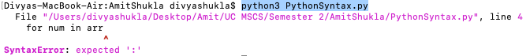
Python has precise syntax, including indentation. As seen in the above example:
  - colon : is missing at the end of the function definition.
  - The for loop is also missing a colon
Syntax errors in Python are caught at runtime before anything in the program runs; the program stops immediately with an error message pointing to the line in question and describing precisely what is wrong.
g++ cppSyntax.cpp -o cppSyntax
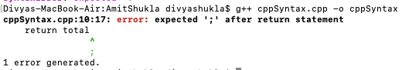
C++ is very particular about semicolons. It wants them at the end of every statement. The missing semicolon after the line "int total = 0" causes the program to fail. This contrasts with other programming languages, such as C++, where syntax errors are checked at compile time. This means your code will not even start to run unless you have fixed any syntax errors.
node javascriptSyntax.js
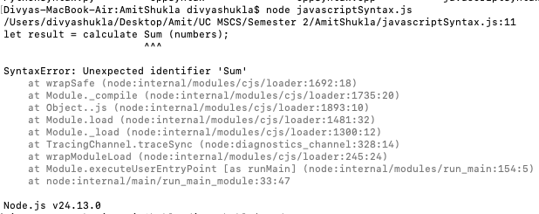
JavaScript automatically catches any syntax errors during this stage of parsing, most commonly when it is first loaded by browsers or Node.js implementations. The error messages should be quite understandable, although there are slight variations in detail across different JavaScript implementations, such as browsers or Node.js.
  - Section 2
g++ cppProg.cpp -o cppProg
node javascriptProg.js
python3 PythonProg.py
Type Systems
  - Python: Dynamic – Types are determined at runtime
  - JavaScript: Weak and dynamic—types can change and get coerced automatically
  - C++: Static and strict—you declare types, and they do not change
Error Control
  - Python and JavaScript: The errors are encountered during runtime, i.e., when the code is executed
  - C++: Error checking is done at compile time before anything is executed.
Performance Impact
  - C++ is the fastest of the bunch since it catches everything at compile time and optimizes heavily
  - Both Python and JavaScript trade some speed in favor of flexibility: they can be written and changed quickly, but they pay in performance
- Part 2: Memory Management:
2.1 Section 3
Rust: Ownership and Borrowing
fn main() {
let v = vec![1, 2, 3];
let v2 = v;
// println!("{:?}", v); // Compile-time error
}
One advantage of Rust is that you are protected against memory leaks as well as "dangling" pointers. This is due to Rust's owner-based allocation—the Rust compiler checks for strict safety violations. Thus, you have memory safety without any overhead due to a garbage collector.
Java: Garbage Collection
public class MemoryTest {
public static void main(String[] args) {
int[] data = new int[1000];
data = null;
System.gc();
}
}
Java uses automatic garbage collection to handle memory cleanup. When objects are no longer in use, and nothing can reach them, the garbage collector frees that memory. This comes at a cost: the developer has little control over exactly when this happens, because the JVM handles it on its own.
C++: Manual Memory Management
int* data = new int[1000];
delete[] data;
C++ provides you with complete control over a program's memory management. However, with complete control comes complete responsibility! If you fail in your responsibility and do not adequately manage your memory deallocations, you may find your system slowly draining its precious resources due to memory leaks! Also, it is common knowledge that trying to delete an object or access its memory after it has already been deleted can lead to so-called "undefined behavior" or "crashing"!
Conclusion:
This assignment demonstrates how programming languages vary in how they enforce syntax rules, how they behave semantically, and how they manage memory allocation and other resources. It is essential to understand how each programming language differs from the others, since the same language chosen to address a particular problem might not provide a suitable solution to a different problem and may even perform worse than other options available.

References
Edwards, J. M. (1992). Development of an object-oriented modelling methodology and its application to a wastewater resources problem. https://doi.org/10.26190/unsworks/8485
Gosling, J., Joy, B., Steele, G., & Bracha, G. (2014). The Java language specification (Java SE 8 ed.). Addison-Wesley.
Sebesta, R. W. (2019). Concepts of programming languages (12th ed.). Pearson.
Stroustrup, B. (2013). The C++ programming language (4th ed.). Addison-Wesley.
Tanenbaum, A. S., & Bos, H. (2023). Modern operating systems (5th ed.). Pearson.
Wirth, N. (1976). Algorithms + data structures = programs. Prentice Hall.

